Regulations and Subsidies

Ruling organisms

Considering the matter of charging stations for EVs, the current situation is a bit blurred. In fact, since the market is still new, and covers new areas in term of technology, the rules are made along the way. The governments and international organizations are adapting the existing rules to the technologies used, but most of the future methods and rules are intrinsically established by the research and companies that build the new EVs park.

A few organisms have adapted rules and started to create some on the EV charging stations matter: National Electrical Code in the US; Centre National du Transport Avancé (CNTA) in Canada (Annexe 1) ; International Electrotechnical Commission; European Environment Grenelle in the EU

Companies and Societies are imposing standards and rules by having the monopole on the edge technology: Society for Automobile Engineers, SAE International; ChargePoint in the US; CHAdeMO in Japan(Tokyo Electric Power Company, Nissan, Mitsubishi and Fuji Heavy Industries)

Existing regulations concern:

**Safety standards**

Exemple: Article 625, Electric Vehicles Charging Systems of the US National Electric Codeg.

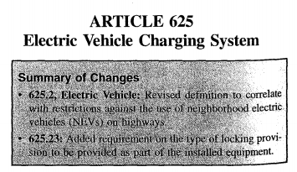

Figure 1: Extract of Article 625 of US National Electric Code

(Reference 1)

**Design standards**

Today, all commercially available charging stations are conductive, that is, the electricity is transmitted through conductors, as in an electrical outlet. Conductive stations are covered by SAE Standard J1772. The voluntary standards of SAE International are often adopted by automakers. All recent EVs, such as the Chevrolet Volt, the Mitsubishi i-MiEV and the Nissan LEAF, are equipped with J1772 sockets.

Another standard for conductive charging stations is CHAdeMO, which covers only DC fast charge stations. Although there are other types of charging stations, this Guide only deals with stations built to one of these two standards.

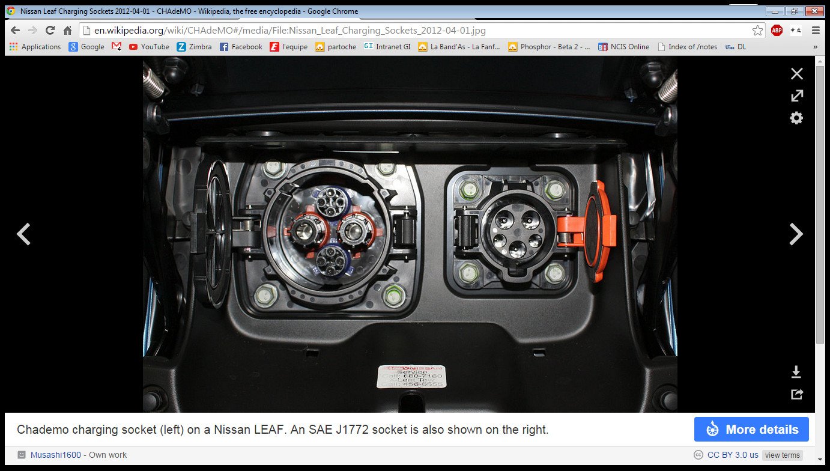

Figure 2: CHAdeMO charging socket on a Nissan LEAF

(Reference 2)

**Rating of the supply voltage**

Voltages should of course match the existing power outlets, but also be able to be implemented in new systems and grids.

**Others**

Charging levels/Modes; Framework (Agents, Grid connection and charging installations, metering, communication and control, EV charging modes, coordination between EVCs and EMC, see Reference 3); General system requirement and interface; Connection between the power supply and the EV (Should at least match the existing characteristics of already developed EVs); Specific inlet, connector, plug and socket-outlet requirements.

Regulations needed & current discussions

Among those actions the call for international or at least European standardization of charging infrastructures and technologies, including smart grids, with open communication standards, should be highlighted.

The currently perceived purchase premiums compared to internal combustion engines are widely being discussed and a multitude of different policy schemes to foster EV adoption is evaluated. (Annexe 2 & 2’)



In addition to technological developments and policy measures, regulatory issues related to investment and deployment of the required infrastructure need to be formulated and adequately solved.

Coherently, there is a need for discussing how and which agents should be authorized to provide EV charging and pricing of those services, as well as how EV storage capability could be appropriately marketed to provide vehicle-to-grid (V2G) services.

Therefore, still many questions remain to be answered within a consistent regulatory framework considering rules and players in existing electricity markets.

As an example of these issues, in California, the Public Utilities Commission has opened a rule making process, in which a number of issues are proposed for consultation with stakeholders. It is yet to be determined (i) how to implement obligatory variable tariffs (ii) legal status of electricity resellers, (iii) incentive creation for users to adopt remote charge control of valuable 2 batteries, and (iv) allocation and recovery of investment in infrastructure in a fair non-discriminatory framework. Furthermore, there exists an intense discussion about critical metering policies in terms of metering arrangements (single, sub-and separate metering) and their implications on cost, installation time, and billing flexibility.

# Annexe 1: Example of a regulation framework in Quebec

REGULATORY FRAMEWORK

6.1 Laws, regulations, codes and standards

The installation of charging stations is subject to several laws, regulations, codes and standards. The laws and regulations stipulate the situations in which you must call in a professional (engineer or master electrician). They also prescribe application of the Québec Construction Code, Chapters I and V. Here is a list of the main documents applicable to charging station installation.

* Québec Engineers Act, R.S.Q., c. I-9
* Québec Master Electricians Act, R.S.Q., c. M-3
* Québec Building Act, R.S.Q., c. B-1.1
* Municipal bylaws
* Québec Construction Code, Chapter I – Building, and National Building Code of Canada 2005 (amended)
* Québec Construction Code, Chapter V – Electricity, C22.10-10, 2010
* CSA, C22.1HB-09: CE Code Handbook: An Explanation of Rules of the CE Code, Part 1
* CSA standards on hazardous locations (see list below)
* Hydro-Québec Standard E.21-10, Low-Voltage Electrical Service (“Blue Book”), 9th edition (2008)

Municipal bylaws, including those on land use and development, must be taken into account in the installation of charging stations. The Québec Construction Code is prescribed by the Building Act, and Chapter V on electricity is particularly relevant to charging station installation. Section 2-014 lists the situations requiring the production of drawings and specifications. The Code and the “Blue Book” are essential tools for charging facility designers. Depending on the nature of the work, other documents such as the Building Code may also apply. The “Blue Book” specifies voltages and methods for connecting Hydro-Québec customers.

Here is a non-exhaustive list of Code sections relevant to charging station installation:

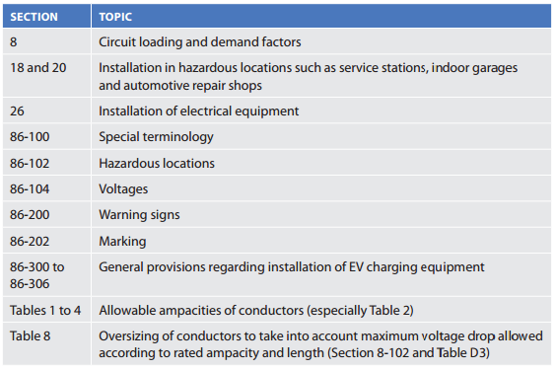

Figure 3: Code sections for charging stations installation

Equipment installed in hazardous locations, as defined in the Code, may be subject to the

following standards:

* CAN/CSA-C22.2 No. 157-92: Intrinsically Safe and Non-Incendive Equipment for Use in Hazardous Locations
* C22.2 No. 213-M1987: Non-Incendive Electrical Equipment for Use in Class I, Division 2 Hazardous Locations
* C22.2 No. 60079-0-07: Electrical Apparatus for Explosive Gas Atmospheres – Part 0: General Requirements
* C22.2 No. 60079-1-07: Electrical Apparatus for Explosive Gas Atmospheres – Part 1: Flameproof Enclosures “d“
* C22.2 No. 60079-2-02: Electrical Apparatus for Explosive Gas Atmospheres – Part 2: Pressurized Enclosures “p“
* C22.2 No. 60079-5-02: Electrical Apparatus for Explosive Gas Atmospheres – Part 5: Powder Filling “q“
* C22.2 No. 60079-6-02: Electrical Apparatus for Explosive Gas Atmospheres – Part 6: Oil-Immersion “o“
* C22.2 No. 60079-7-02: Electrical Apparatus for Explosive Gas Atmospheres – Part 7: Increased Safety “e“
* C22.2 No. 60079-11-02: Electrical Apparatus for Explosive Gas Atmospheres – Part 11: Intrinsic Safety “i“
* CAN/CSA-E79-18-95 (R2009): Electrical Apparatus for Explosive Gas Atmospheres – Part 18: Encapsulation “m“

Lastly, SAE Standard J1772 on AC charging stations encompasses all applicable UL and CSA

Standards, but is not mandatory.

# Annexe 2: Research proposal

(Reference 3)

**Existing agents:**

* Distribution system operator (DSO): owner and operator of the distribution good (generally a monopoly)
* Supplier : the agent that sells energy to final customer
* Final customer: agent requiring electricity; forbidden to resell electricity. He can be residential, commercial or industrial customer
* Independent System Operator (ISO) or transmission system operator (TSO): responsible for keeping a secure system operation at the regional or national transmission level. He can procure system services, like operational reserves and frequency regulation, from market participants.

**New agents:**

* Plug-in electric vehicle owner (EV): owns an electric vehicle and wants to charge its battery
* EV supplier-aggregator (EVSA): agent selling electricity to the EV owner
* EV charging point manager (CPM): acts as a final customer for electricity, he is assumed to install the charging infrastructure. He can buy the electricity to charge his own EV or resell it to other EV owners connected to the charging station under a commercial agreement. The access to the charging stations depends on the terms and conditions it sets; but it should obtain a license to exercise this activity, like technical capability and financial liability. He could be:
  + a residential customer who installs the charging station at home for private use
  + an office building owner who installs the charging station in the office parking area for the private use of the employees
  + a commercial building owner who installs the charging stations for the use of its clients
  + a charging station owner who installs the charging stations to deliver this service for the public
  + If the charging station is installed in a public area, the business is regulated and charging stations developed by the corresponding DSO in the area. The access is universal to EV owners contracted with different EV suppliers.

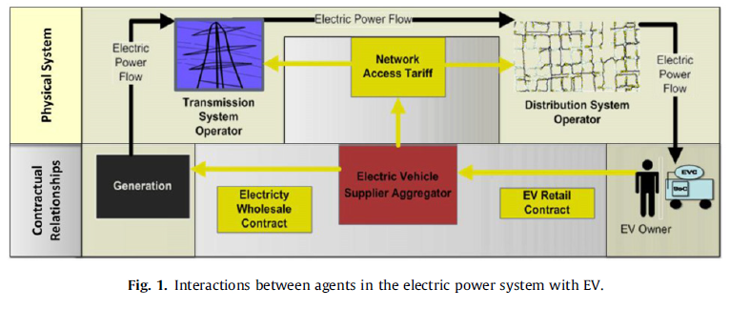

**Grid connection and charging installations:**

* Distribution grid
* Final customer connection point
* EV charging infrastructure
* EV charging point or charging post (CP): is the connection point between the Ev and the charging infrastructure, where the EV is plugged-in to be charged. A single or multiple charging posts would make up a charging station.

**Metering, communications and control**

* Final customer meter (FCM): it is located at the final customer connection point. It is known as the ‘‘utility meter’’. It meters the energy consumption (kWh) and peak consumption (kW) in a period of time. Measurements can be collected by time- of-use, in peak and off-peak hours for instance
* EV meter (EVM): would meter the energy consumption, the peak consumption and the period of time during which an EV has been connected to a charging point for billing purposes. EV meters can also be embedded in the car. In some cases, EV meters would communicate with the EV supplier for billing and potential remote charging control.
* Energy manager controller (EMC): is a controller, similar to an energy management system or energy box, operated by the corresponding CPM or EVSA (Livengood and Larson, 2009). It schedules a charging programme for each of the connected EVs.
* Electric vehicle meter (EVM): it provides information about energy consumption, peak consumption, and times of connection on request.
* On-board EV state of charge indicator (SoC): measures the state of charge of the EV battery as a percentage of the full charge or in kWh.
* On-board EV controller (EVC): is a programmable controller that provides a menu of alternatives to the EV owner for charging the EV battery during its connection period.

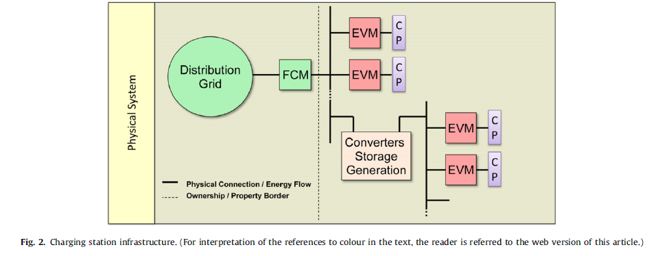

# Annexe 2’: Exemple of the EV home charging

Agents involved: the home owner, the supplier, and the DSO. The home owner will notify the supplier about the maximum required charging power whereas the supplier will notify the DSO if additional power demand is required under the supply contract (Fig. 4).

Contracts: The supply contract between the supplier and the residential final customer would be a contract with at least ToU prices, i.e. peak and off-peak prices to promote charging at off-peak hours, or it could be a more sophisticated contract with hourly time prices that promotes an integrated management of the EV with the rest of the loads. In this case the FCM should be upgraded to a smart meter in order to measure hourly consumptions. The supplier will pay the DSO for the corresponding regulated network charges.

Communication and charge control: The EV owner would programme his EVC in accordance to his/her driver requirements and simultaneously minimizing electricity payments to the supplier. The supplier can offer the home owner an integrated management of his loads as well. In optimization mode there needs to be a communication of price signals between the supplier and the EVC.

Settlement: The settlement of the contract would be based on the total home electricity consumption according to the prices set in the contract. These prices in general would be: (i) a demand charge (h/kW-month), and (ii) an energy charge (h/kWh) with different ToU rates or hourly prices. Under the scheme of mode HO-SA-UCO, as presented above, it is not possible to bill the electricity used for transportation differently from domestic energy consumption. If this was the intention, as for instance necessary when including special rates or taxes on transportation, the connection of the EV charging point should be metered too. In Fig. 5 two independent meters are installed for this purpose. A series connection with subtractive calculation for billing would also be possible (PG&E, 2010). In these cases, the home owner could have two different supply contracts or rates, the former for billing the home electricity consumption and the new one for EV charging with an EVSA for instance.

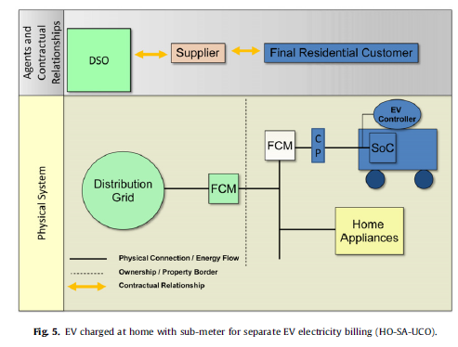

# References

Reference 1 :

<http://www.calstart.org/Libraries/E-Truck_Task_Force_Documents/Article_625_Natl_Electric_Code.sflb>.ashx

Reference 2 :

<http://www.hydroquebec.com/transportation-electrification/pdf/technical-installation-guide.pdf>

Reference 3:

“Regulatory framework and business models for charging plug-in electric vehicles: Infrastructure, agents, and commercial relationships - Tomas Gomez San Roman, Ilan Mombern, Michel Rivier Abbad, Alvaro Sanchez Miralles”

Sources

<https://www.rvo.nl/sites/default/files/2014/04/Electromobility%20in%20the%20Netherlands%20Highlights%202013.pdf>

<http://www.acea.be/search/de7db054743d8d51591526e8c57a5d02/>

<http://www.acea.be/publications/article/overview-of-incentives-for-buying-electric-vehicles>

<http://en.wikipedia.org/wiki/Government_incentives_for_plug-in_electric_vehicles>